

Addis Ababa university

FACULTY OF NATURAL AND COMPUTATIONAL SCIENCES

DEPARTMENT OF COMPUTER SCIENCE

**Blockchain**

technical report writing

by

ADDISMIRAPH ABEBE NSR/2009/08

BIRUK TAMIRU NSR/9151/08

AMANUEL SHIMELES NSR/6860/08

Advisor: Berhanu Abebe

January 2019

DECLARATION

This is to declare that this project work which is done under the supervision of Berhanu Abebe and having the title AAU Push is the sole contribution of:

ADDISMIRAPH ABEBE NSR/2009/08

BIRUK TAMIRU NSR/9151/08

AMANUEL SHIMELES NSR/6860/08

No part of the project work has been reproduced illegally (copy and paste) which can be considered as Plagiarism. All referenced parts have been used to argue the idea and have been cited properly. We will be responsible and liable for any consequence if violation of this declaration is proven.

Date: _____________________

Group Members:

Full Name Signature

___________________________________ ________________________________

___________________________________ ________________________________

___________________________________ ________________________________

CERTIFICATE

I certify that this technical report entitled

Blockchain by:

ADDISMIRAPH ABEBE NSR/2009/08

BIRUK TAMIRU NSR/9151/08

AMANUEL SHIMELES NSR/6860/08

is approved by me for submission. I certify further that, to the best of my knowledge, the report represents work carried out by the students.

____________________________ ____________________________

Date Name and Signature of Supervisor

**Table of Contents**

DECLARATION i

CERTIFICATE ii

List of Figures v

1. Introduction 1
   1. Background 1
   2. Bitcoin - First Application of Blockchain 2
   3. A Brief History of Blockchain 3
2. Literature review 4
   1. Introduction 4
   2. Working Model 5
      1. What is a Block? 5
      2. Core Concepts 7
   3. Uses of Blockchain 8
3. Related works 10
   1. Introduction 10
   2. Cryptocurrency 10
   3. IOTA and Tangle 10
      1. The Tangle - A Data Structure 11
4. Applications of blockchain 12
   1. Importance of Blockchain in Healthcare Data Management 13
   2. Blockchain & Healthcare 13
   3. Pharmaceuticals And Fraud Detection 14
   4. Drug And Food Supply Chain 14
   5. Blockchain And Government 15
      1. Land Registry 15
      2. Elections 16
5. Future work 18
   1. Introduction 18
   2. Blockchain and the humanitarian sector 18
      1. Protected data sharing 18
      2. Supply chain 18
      3. Identity 19
   3. Blockchain and governance 19
   4. Smart contracts 19
6. Conclusion 21

References 22

List of Figures

1. Introduction
   1. Background

Since the invention of the Internet and the World Wide Web, we have seen an unprecedented change in the way we live. Today, everything is a click away. Do you need a pack of pens? Click and Amazon will send it to you. Do you need a ride to a friends house? Click and an Uber or a RIDE will show up. In this whole process, the use physical cash is slowly disappearing. Electronic cards and online bank account transactions have simplified our payment systems. Social media applications made by companies like Google and Facebook have made connecting with distant friends and relatives easier than ever. Using instant-messaging applications, we are able to chat in realtime with people across the world. After seeing all the advantages we get from the Web, are there any disadvantages?

The inventor of the World Wide Web, Tim Berners-Lee, has seen this evolution of his brain child through the decades. He saw the utility it brought to humanity. However, he is now confronted with an alarming future and is devastated by it.[1] This concern arises from the way in which the Web has developed. We live in a centralized world. From social media apps to financial activities, we give our personal information to be stored in that service’s server, wherever it might be in the world. This has put users, who have lost control of their data, at the mercy of service vendors.

“Centralization, or control by a single authority or entity, is a common and pervasive form of governance. Governance refers to principles of organization and power. We must trust central authorities, like banks, governments, and other institutions to maintain order and structure within the space they operate. This trust is broken when the central authorities can not maintain that order and structure. For example, if your credit card information is stolen from the database of a bank you transact with, the centralization of your information in this bank has been used against you. Centralized technology and data allows for both the monopolization of power and creates a security risk.” (ConsenSys Academy, 2017)

This poses a single point of failure for the whole system. The Blockchain technology saw it debut in the financial sector in 2009, when it was used to host a cryptocurrency known as Bitcoin. Blockchain combines a number of known technologies to create a distributed public ledger (database for transactions) that is cryptographically secure against modification, ensuring identity and integrity. After its success, the blockchain platform has been in development to be applied to many other areas.

* 1. Bitcoin - First Application of Blockchain

“The one thing that’s missing is a reliable e-cash, whereby on the internet you can transfer funds from A to B without A knowing B or B knowing A” - Nobel Prize Winning economist Milton Friedman, 1999

Almost 10 years later, on October 31, 2008, in the midst of the financial crisis, Satoshi Nakamoto (an alias for a still unidentified individual or group of individuals) published the Bitcoin Whitepaper, titled Bitcoin: A Peer-to-Peer Electronic Cash System.[2] This paper described a way of exchanging a currency, Bitcoin, that combines cryptography, computer science, and game theory in its design and implementation. Satoshi’s creation enabled a participant to digitally transact directly with another participant without relying on a single, centralized intermediary, such as a bank, to validate the payments. Bitcoin was able to do this by using and running on what it called a blockchain. **Blockchain** is distributed, decentralized, public ledger. It is made up of blocks that hold data and each block is cryptographically connected to ensure integrity. In the case of Bitcoin, each block holds the transaction information.

This decentralized nature of blockchain has made it:

* Less likely to fail because they rely on many separate components.
* Harder to attack because the networks are spread across many computers.
* Harder for users with malicious intent to take advantage of users who are using the platform for its intended purpose.

If one node stops working, or even 100 nodes, the blockchain survives assuming there is at least one node up and running. This makes the blockchain very resistant to attacks. The blockchain does not stop working even if the power is lost in an entire country. This makes the blockchain very resilient, which cannot be said of many of the existing systems we use on the Internet.

* 1. A Brief History of Blockchain

The technique used in blockchain to ensure integrity of data was first described in 1991 by Stuart Haber and W. Scott Stornetta in their article title “How To Time-Stamp a Digital Document” in the Journal of Cryptography. They raised “the issue of how to certify when a document was created or last changed.”[3] Since it was easy to modify the date of creations or edit of a document using different tools. They saw the need to time-stamp the data itself and “propose[d] computationally practical procedures for digital time-stamping of such documents so that it is infeasible for a user either to back-date or to forward-date his document, even with the collusion of a time-stamping service.”[3] They created with technique to make sure that the privacy of the documents were maintained and required no record-keeping by time-stamping services.

The first blockchain was conceptualized by a person or group known as, Satoshi Nakamoto, in 2008. The design was implemented the following year by Nakamoto as the core component of the implementation for the Bitcoin digital currency.

In the following chapters of this paper, we will look at how this technology works, its applications and the exciting future it holds.

1. Literature review
   1. Introduction

So what exactly is a Blockchain? The term blockchain is still yet to be defined with clarity and agreement. Currently it can refer to a data structure, algorithm, a group of technologies, and/or as a definition used for distributed peer-to-peer systems with a common application system.

A blockchain is essentially a distributed database of records or public ledger of all transactions or digital events that have been executed and shared among participating parties. Each transaction in the public ledger is verified by consensus of a majority of the participants in the system. And, once entered, information can never be erased. The blockchain contains a certain and verifiable record of every single transaction ever made. [4]

Blockchain is a vast, global, distributed database. That doesn’t run on one computer rather runs on all computers and is not accessible to a few but accessible to all. And not just to information but potentially anything of value, money, financial asset, intellectual property, energy, even votes and elections can be moved, stored and managed securely and privately and where trust is not established by a third party but rather through mass collaboration, Cryptography and cleaver code.[5]

Block chain is a distributed ledger that is completely open to anyone. It has many properties that make it appealing — one of which is that when something it written to the blockchain, it is very hard to reverse it.

Key Features Of Blockchain:

* Decentralization – Blockchain works on the principle of decentralization, it means that the information is not stored on a central server, rather, its distributed.
* Provenance – This is yet another important feature of Blockchain wherein it becomes easy to track the origin of the product. This feature is very useful in supply chain management.
* Immutability – This feature of Blockchain makes it difficult for anyone to change or alter the data. Once the information is fed in the ledger, it gets time-stamped and changing this information becomes nearly impossible.

Blockchain is a smart combination of known techniques. It is a shared, replicated ledger with consensus, provenance, immutability and finality. In the following sections, we will look at each component of a blockchain and how it works.

* 1. Working Model
     1. What is a Block?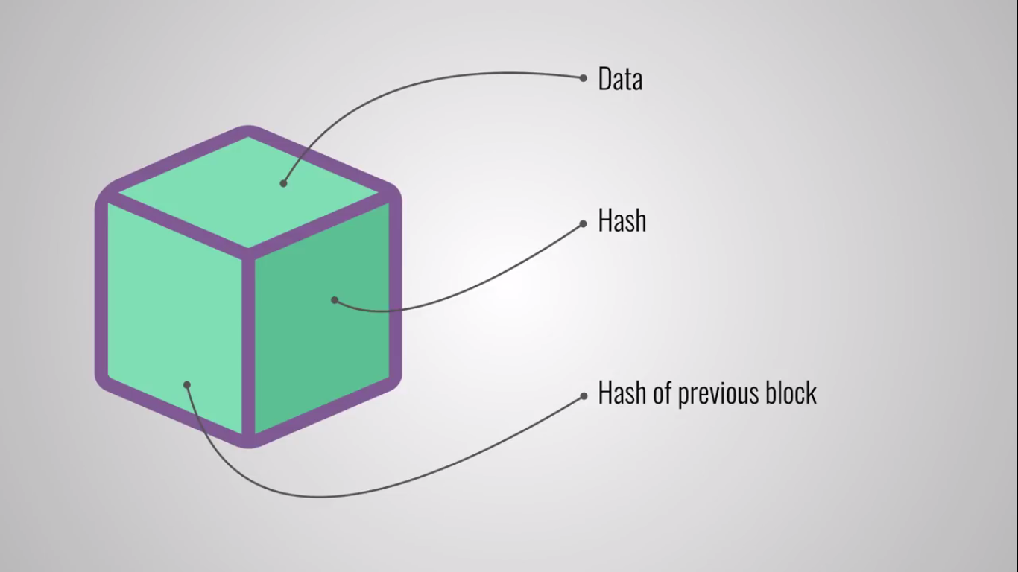

**Block:** A block is simply a file that hold three main components: data (main content of the block), hash of the previous block, hash of the block. Let’s look at each part closely.

**Data:** the contents of the data stored within a block can differ from one blockchain to another depending on the purpose of the blockchain. For Bitcoin, a number of transactions are stored within the block. Figure below shows the blockchain of Bitcoin.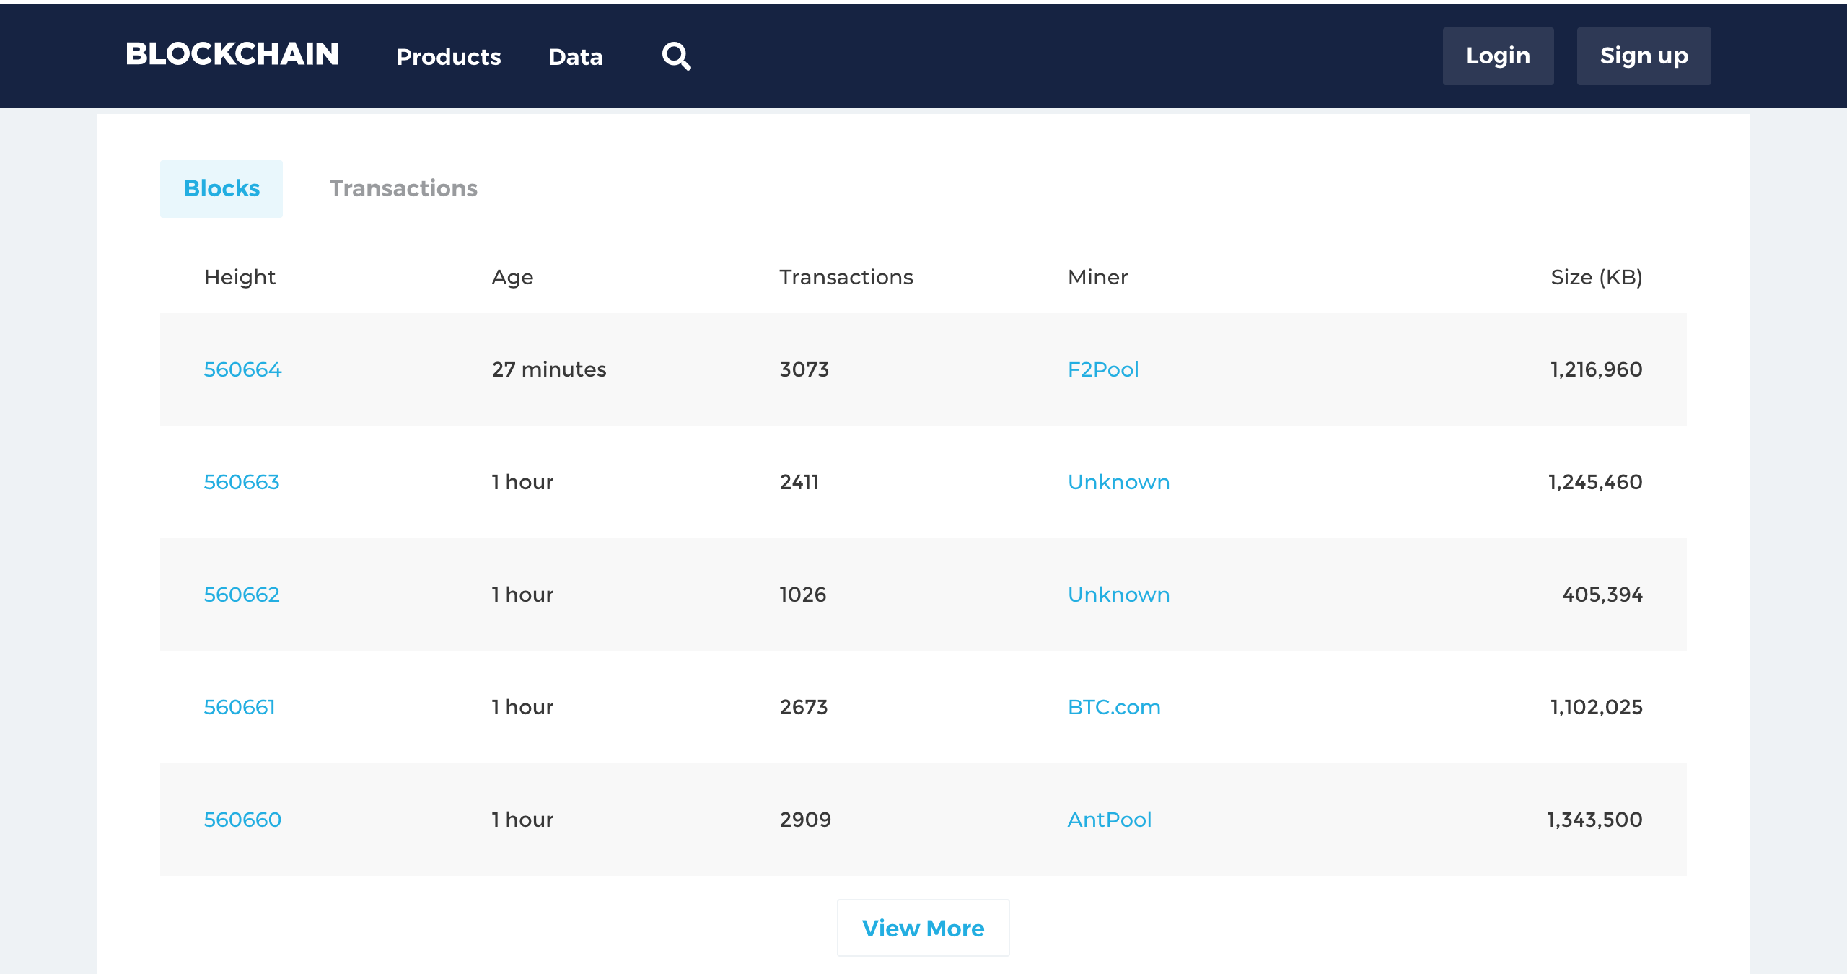

Each row is a block and the ‘Transactions’ column shows the number of transactions recorded or stored in that block. The file column titled ‘Size’ shows the space that block file takes.

For other blockchain, the data stored might be completely different. For example, the blockchain is used for food supply chain management, the data for one block could contain ‘Batch Number,' ‘Date of Production,' ‘ID of Transport Truck,' ‘Temperature Level in Truck,' ‘Humidity,’ and ‘Date of Delivery.’

**Hash:** To give each block a unique identification, a hashing algorithm is used on the contents of the block — reducing it to a string or number of a given length. The data of the block is hashed together with the hash output of the previous block on the chain. This creates the chain and associates each block to the one before it. Hashing makes it easy to check if the contents of the block is edited or not.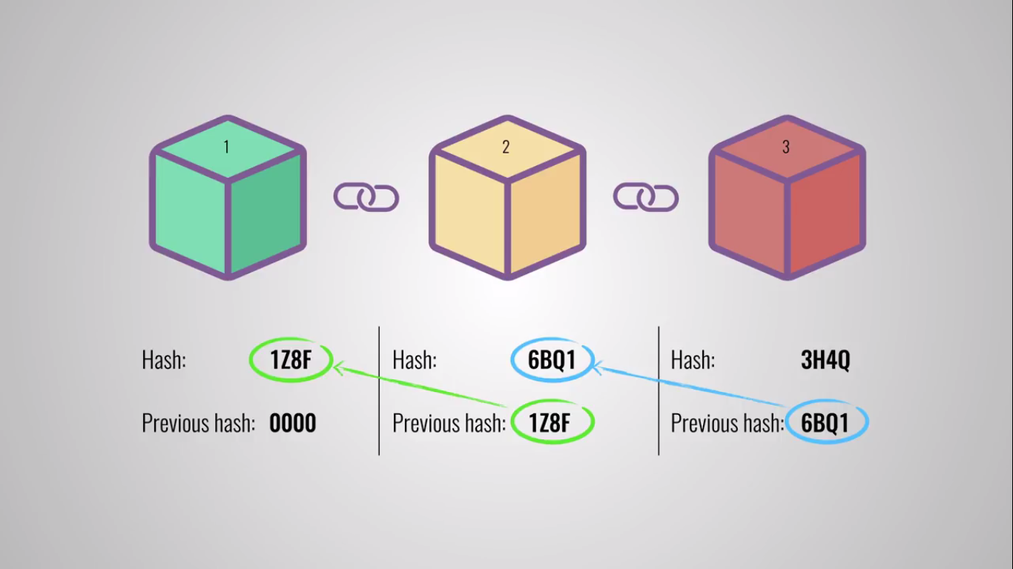

**Hash of Previous Block:** The third important component of a block is including the hash of the previous block. The figure above illustrates how the blocks are connected with hashes.

The first block of a chain is called the Genesis block. It is the only block that does not contain a hash of a previous block.

Let’s say an attacker tampers with the contents of one block. That would change the hash for that block. Because the next block contains the hash of the edited block, the hash for the next block would also change. And this would go on to the end of the blockchain. That means the whole chain is different because of one small adjustment. This is what makes blockchain hard to tamper with.

* + 1. Core Concepts

**Decentralization:** to remove the risk that comes with storing all data centrally, in blockchain, data is stored and replicated across all nodes across its peer-to-peer network.

Node - a computer connected to the blockchain network that performs the task of validating and relaying transactions — which gets a copy of the blockchain, which gets downloaded automatically upon joining the blockchain network.

Every node on the blockchain has a copy of the block chain. Because there is no central authority, there is no ‘official copy.’ Each node has the data. When a new block is added to the chain, it is broadcasted to all on the network. Each node will then update its local copy to reflect the latest chain available.

Any node can create a new block to add to the chain. But since there is no central authority of regulate and check it is a valid block, there needs to be a protocol on the network that ensures each block added is valid. The process of a block being accepted as valid by nodes is called consensus.

**Consensus:** is an agreement across all nodes that a block is valid and should be added to the chain.

There are several ways used to achieve consensus. The one used the most currently is consensus through proof-of-work. This process requires the node adding the block to do a costly computation to prove that the block is valid.

**Asymmetric Key Cryptography:** The blockchain network utilizes the capabilities of public key cryptography for secure operation of the blockchain. The private key of a user is used to generate digital signatures and show ownership. The public key is used as a pseudonym user address.

* 1. Uses of Blockchain

There are various areas in academics where Blockchain and its key features can be used. Let us analyze them.

* Data Management – Every year there are thousands of students that enroll in college and universities. Though we have a digital system nowadays still most of the work remains in the paper. Thus, finding particular data from the pool of so many data not only becomes time-consuming but also a tedious task. But having all the information fed on the ledger will make it easy for people associated with it, easily extract any piece of information without any delay.
* Digital identity — with the changing times, there is a huge demand for digital identity. With the help of Blockchain technology, we can give complete control of one’s personal data to individuals and this would lower the cost of the data management system and personnel. Basically, Blockchain will bring a huge transformation from a paper-based system to a paperless system.
* Data Verification – This is another area where Blockchain can prove to be extremely beneficial in this sector. With the help of Blockchain, we can easily verify data. Once the data or information of student is entered in the ledger it gets time-stamped and then altering the data is not possible. Since every information or block is associated with another, changing one data would require the hacker to change 6 other blocks which are a nearly impossible task. Thus, the Blockchain based system in higher education can be used for data verification. This becomes even more important in times like today when we need system from where we can easily track the data and also ensure that the information is authentic.
* New Job Prospect – Another key area where Blockchain can prove beneficial is introducing it as a part of our curriculum. We know that the world is slowly realizing the importance of Blockchain and with companies like Facebook creating a spate division for Blockchain based development, the future holds a lot of opportunities for students. Many institutes have introduced Blockchain as a part of regular education.
* Smart Contracts – Well, whenever we talk about Blockchain, then often smart contracts are associated with payments but, its application is huge. Institutes can use this technology to hand over certificates and degrees once the student successfully clears the exams on the parameter set by the institute.

Blockchain technology has come a long way from its origin as a financial instrument that was free from the control of any world government or corporation. But as the blockchain mania of the last two years has shown us, blockchain’s use case goes far beyond what was initially thought possible. The new use case for blockchain is largely attributed to the second generation of blockchain platforms like Ethereum which enabled smart contract functionality.

1. Related works
   1. Introduction

Since the invention of bitcoin in 2008, and along with it blockchain, the tech world has been alert in democratizing power of data by introducing decentralized and distributed systems.

In this chapter we will see technologies related to blockchain.

* 1. Cryptocurrency

A cryptocurrency (or crypto currency) is a digital asset designed to work as a medium of exchange that uses strong cryptography to secure financial transactions, control the creation of additional units, and verify the transfer of assets.[6]

A cryptocurrency works through a distributed ledger, usually blockchain, to be a public financial database. There are two important keywords that need loose definitions - a coin and a token. A coin is a cryptocurrency associated with a specific blockchain. Bitcoin is the coin for the Bitcoin blockchain. Ether is the coin for the Ethereum blockchain. A token however is a digital representation of something. It could be a service, a car, an idea or anything else.

Today there are hundreds of cryptocurrencies, with Bitcoin and Ether being the most famous.

* 1. IOTA and Tangle

IOTA is a permissionless distributed ledger for a new economy. [7] It seeks to solve the same problem that blockchain does — lack of trust and security of centralized ways of governing. However, it also seeks to solve the inefficiencies seen in blockchain:

“As blockchain adoption has increased over the last decade, early adopters have been hit with sluggish transaction times and skyrocketing fees. As financial rewards for validating blockchain transactions became increasingly competitive, their networks have also become increasingly centralised around a few powerful actors.”[7]

In order to do this, IOTA depends on a data structure called Tangle. IOTA’s distributed ledger is not stored in a linear sequence of blocks. All transactions are entangled together. Have a look at the figure below: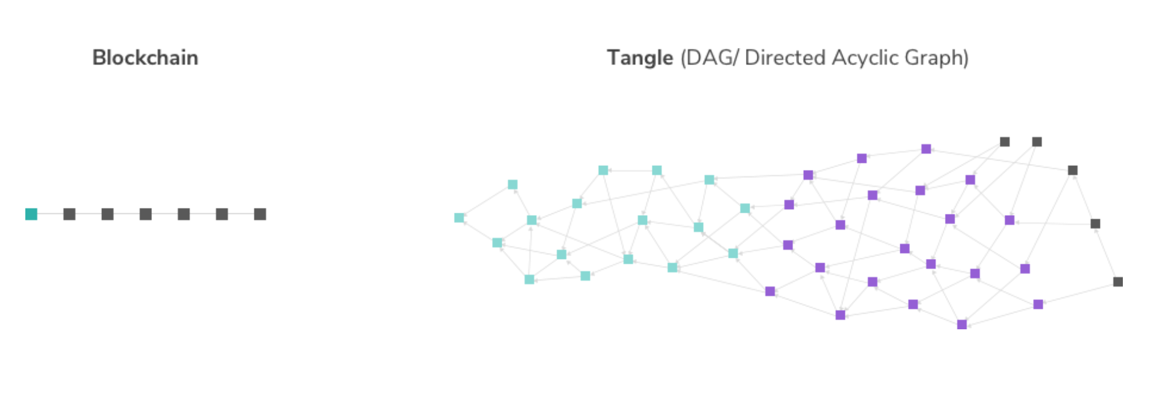

“In order to participate in this network, a participant simply needs to perform a small amount of computational work that verifies two previous transactions.” [7]

Therefore tangle removes the need for the ‘miner’ position in blockchain because the computational work is not hard and every member can be in charge of validating transactions. Each actor verifies two translations to add their own transaction to the tangle. Every participant does work and is rewarded. This makes IOTA completely free from transactional fees. The more activity there is the more validations result. This makes IOTA a scalable system as well.

The IOTA Tangle also has its own coin, IOTA coin.

* + 1. The Tangle - A Data Structure

The IOTA Tangle is a stream of interlinked and individual transactions. These transactions are distributed and stored across a decentralised network of participants.[8]

Nodes within the tangled represent transactions, and edges represent approvals. Approving a transactions is checking whether its history is true and valid.

The Tangle is similar in spirit to a blockchain, but overcomes some of its fundamental limits.

* Scaling: the Tangle does not have a built in maximum throughput.
* Fees: there are no miners, and therfore no miner fees. Each transaction sends the full input amount.
* Miners versus users: IOTA has no miners, and therefore no incentives to slow the network down to raise fees, and other conflicts of interest. [8]

1. Applications of blockchain

Blockchain technology has the potential to upend the way every industry manages its information and data, not only financial services.

Imagine being able to track shipments through your supply chain with ease, down to the individual package or even component level. Or, executing a contract with a vendor without the need for an intermediary auditor. Blockchain can even help verify materials and food sourcing to ensure health and ethical standards are maintained.

The potential industry disruptions included are-

Legal: “Smart contracts” stored on the blockchain track contract parties, terms, transfer of ownership, and delivery of goods or services without the need for legal intervention.

Supply Chain: By utilizing a distributed ledger, companies within a supply chain gain transparency into shipment tracking, deliveries, and progress among other suppliers where no inherent trust exists.

Government: Blockchain offers promise as a technology to store personal identity information, criminal backgrounds, and “e-citizenship,” authorized by biometrics.

Energy: Decentralized energy transfer and distribution are possible via micro-transactions of data sent to blockchain, validated, and re-dispersed to the grid while securing payment to the submitter.

Food: Using blockchain to store food supply chain data offers enhanced traceability of product origin, batching, processing, expiration, storage temperatures, and shipping.

Retail: Secure P2P marketplaces can track P2P retail transactions, with product information, shipment, and bills of lading input on the blockchain, and payments made via Bitcoin.

Healthcare: Electronic medical records stored in a blockchain, accessed and updated via biometrics, allow for the democratization of patient data and alleviate the burden of transferring records among providers.

Insurance: When autonomous vehicles and other smart devices communicate status updates with insurance providers via the blockchain, premium costs decrease as the need for auditing and authenticating data vanishes.

Travel and Hospitality: Passengers store their authenticated “single travel ID” on the blockchain for use in lieu of travel documents, identification cards, loyalty program IDs, and payment data.

Education: Educational institutions could utilize the blockchain to store credentialing data around assessments, degrees, and transcripts.

* 1. Importance of Blockchain in Healthcare Data Management

**Healthcare Industry Rife With Data Breaches**

The last few years have seen several high profile cyber attacks in healthcare systems across the world. Perhaps none was more shocking and enormous than the hacking of United Kingdom’s National Health Service (NHS) on 12 May 2017. The UK spends over £125 billion every year on the NHS which has over 100,000 doctors and close to 400,000 support staff. The NHS treats more than 64 million patients every year in the UK and 54 million patients in England alone. The hack which was part of the larger wave of cyber attacks called “WannaCry” ransomware affected over 300,000 computers worldwide and brought the NHS to its knees. The  WannaCry exploit was reportedly distributed via email attachments and could propagate itself throughout the network from one infected machine. Once the exploit had been replicated to a large number of machines, the payload was delivered in the form of locking up all of the files on the computers by encrypting them to prevent access. Then the hackers demanded payments in untraceable cryptocurrencies in order to give back access. Affected areas were severely hit in their ability to treat patients and estimates put the number of deaths due to the hack at close to 900.

* 1. Blockchain & Healthcare

Due to their decentralized nature, blockchain has a very large amount of computational power backing them up which makes it virtually impossible for them to get hacked. Blockchain also allows for users on the internet to be securely identified using their cryptographic private keys. These two properties of blockchain can be combined to create data management systems that are completely resilient to hacks because they don’t suffer from a single point of failure.

In fact, ID management companies are using blockchain for this very purpose – they upload a digitally verified copy of a user’s ID documents like passports or driving licenses to their blockchain. Later, when an entity requests access to that document, the user gets a prompt on their phone from which they can choose to allow or deny the request. The same model can be applied to healthcare records as well so that people are not left in the dark about their sensitive information being exposed like in the case of a hack. This also has the added advantage of simplifying data provenance – users can opt-in to share the medical data with researchers anonymously so that their results can be used to develop better treatments in the future. Also since there are no middlemen in this transaction, healthcare researchers can be sure that data integrity has not been compromised.

The current literature surrounding blockchain and the healthcare industry indicates promise in simplifying an array of healthcare data transactions on both the business and clinical sides of healthcare--from claims adjudication to precision medicine.Centered at the core of such discussions is the concept of interoperability across a range of stakeholders. Capitalizing on this technology has the potential to connect fragmented systems to generate insights and to better assess the value of care.

* 1. Pharmaceuticals And Fraud Detection

Not unlike cryptocurrency transactions, blockchain technology can be used in a similar fashion to monitor the production and distribution of pharmaceutical drugs. Mettler (2016) notes that in 2010 the World Health Organization estimated “[10%] of drugs are counterfeit worldwide” with increases as high as 30% in developing countries. Pharmaceutical products include lifestyle supplements and “also drugs for the treatment of cardiovascular disorders and cancer, antibiotics, painkillers, contraceptives and other[s]”. The World Health Organization notes that counterfeit pharmaceuticals often include the correct active ingredient in a higher or lower than stated dose, causing adverse or undesired reactions (WHO, 2010).

* 1. Drug And Food Supply Chain

Medical supply chain may benefit from blockchain technology to help protect public health. Such systems can trace the origins of drugs by logging time series drug transaction data generated by IoT sensors to a blockchain to prevent counterfeits. The record of drug transactions among manufacturers, wholesalers, retailers, pharmacies, hospitals, and consumers, can turn the drug supply chain from regulating (government audits) to surveillance (by every participants collaboratively) .

* 1. Blockchain And Government

Douglas (2017) observed that blockchain technologies offer innovative solutions for two of the most persistent problems currently faced by governments – the establishment of identity records, and the creation of trust in digital environments. Such elements are crucial to the success of nation-states, as:

* + “untrustworthy civil registration entries may mean that citizens are unable to prove their identities as a necessary precondition of accessing social protection benefits, or that opportunities for identity fraud emerge that undermine a country’s immigration policies and national security”

Three emerging areas within the literature surrounding blockchain implementation include identity records and the case of e-Estonia(country that first implemented E-identification for residents), land registry systems in both the Western and developing world, and emerging theories on the potential use for democratic elections and other third-party voting systems.

* + 1. Land Registry

A land registry typically refers to the means by which a government agency records matters of ownership and rights to land; this may include evidence of title, and the facilitation of possession transactions, with the intent to prevent unlawful or fraudulent activities.

The advantages of blockchain in this instance are twofold.

* First, creating an accessible land registry utilizing blockchain technology allows citizens a new means of participation — in both registering assets, and in verifying legitimacy of current land titles. With transactions placed on a private blockchain, the subsequent cryptographic hash is:
  + made public on the Bitcoin blockchain to verify the authenticity of certificates. The hash serves as a digital fingerprint allowing anyone to verify that the data matches what is on the blockchain without actually seeing the data itself.
* Second, a land registration transaction in the Republic of Georgia historically requires at least 24 hours processing time with a fee, paid in-person by a buyer or seller to a registry house; under the blockchain system, fees to buyers and sellers are “in the range of $.05-$.10[USD]” with subsequently reduced processing timeframes .
  + 1. Elections

In lieu of current paper-based systems of voting, blockchain offers a solution in conjunction with the use of i-voting (where votes can be cast using a web browser) and/or e-voting (electronic votes tallied at a polling station). The aims of digital voting systems utilizing blockchain are twofold: first, to provide an unprecedented level of voter privacy, and second, to ensure each voter is unique and able to ensure their vote is tallied as cast. In considering the efficacy of such suggested digital systems, several social assumptions are made: that a country or jurisdiction utilizes a system of constituency based voting, that all voters have been assigned a unique identifier or other form of reference, and in the case of e-voting, a reliable network connection must be present at all polling stations (Barnes, Brake and Perry, 2016).

* RETAIL INDUSTRY: THE EXCHANGE OF GOODS & SERVICES

Much of the current blockchain literature focuses on establishing systems of trading for non-physical assets, be they digital or financial. However, emerging trends also exhibit a natural evolutional interest in a decentralized marketplace for both goods and services.

* MEDIA, CULTURE AND ENTERTAINMENT

Intellectual property protection for digital media is also a common blockchain application. The system in proposes to register self-embedding watermarking processed images on the blockchain in order to preserve transaction trails and content modification histories, and provide tamper detection for digital image management and distribution.

Blockchain technology application transforms the roles of third party intermediaries in the media industry, making artists' careers more sustainable by improved overall transparency of the value chain.

1. Future work
   1. Introduction

Currently, blockchain is a relatively new technology and its full potential or what can be done with it isn’t fully explored yet. But, researchers and experts say the future is bright for blockchain in many industries. Blockchain could be the go-to choice for any sector or industry if they want to keep their data as transparent, accountable for, secure or tracked. Many industries have shown interest in blockchain, like financial services, health care, technology, public sector, food and so much more. Many executives in major companies across the globe are open-minded about this new type of database, the blockchain. As Deloitte’s survey shows, executives think blockchain is faster, more secure, reduces cost and they even think it could be a revenue source.[9] More than half of the companies in the survey are willing to invest more than a million dollars on blockchain in the coming year. Despite all its advantages, many people think blockchain could disrupt many industries and cost a lot of people their jobs.

* 1. Blockchain and the humanitarian sector

Blockchain has the potential to provide substantial benefits in the humanitarian sector. By using blockchain technology this sector could benefit from transparent, efficient form of data and data management. Let’s see some potential use cases for blockchain in the humanitarian sector as proposed by Vanessa K and Andrej V. [10]

* + 1. Protected data sharing

Unreliable information and information silos between different humanitarian sectors is often a problem in humanitarian information management. Blockchain could overcome this problem by providing a information marketplace that is publicly accessible. It would secure and different agencies would be able to collect and share data on the same network.

* + 1. Supply chain

Humanitarian supply chains are extremely dynamic. As a result, supply chain visibility and data tracing can often be poor. Blockchain’s transparent and public ledger can greatly improve humanitarian operations by providing data to inform more effective and accurate decisions, enabling evidence-based interventions and management, exposing issues for effective remedy and increasing accountability.

* + 1. Identity

A lack of identity documentation is a key challenge in humanitarian response and early recovery systems. The blockchain can provide accessible and verifiable identification in humanitarian and disaster situations. With this, it is possible for a person to prove their existence and identity through a distributed public ledger, akin to an international public notary. This enables a decentralized personal data-management system that individuals own and control themselves.

* 1. Blockchain and governance

Dubai will be the first blockchain powered government. Dubai plans to be the first city fully powered by blockchain in 2020. Dubai government will go completely paperless in 2021, by eliminating more than 1 billion pieces of paper, this could be possible by the use of blockchains.

"Adopting Blockchain technology Dubai stands to unlock 5.5 billion dirham in savings annually in document processing alone — equal to the one Burj Khalifa’s worth of value every year." The Dubai Blockchain Strategy establishes a roadmap for the introduction of Blockchain technology for Dubai and the creation of an open platform to share the technology with cities across the globe. The Dubai Blockchain strategy is built on three pillars of government efficiency, industry creation and international leadership.”[11]

The Dubai Blockchain Strategy will help Dubai to create the future of Dubai, and make Dubai the happiest city on earth.

* 1. Smart contracts

Smart contracts is a feature found in ethereum, the second most valuable blockchain. Smart contract lets a group of people make deals and contracts between themselves in a way that would make the contracts execute when the specified terms and conditions are met. Smart contracts are layered applications that run on a blockchain. Smart contracts are contracts that are set to execute when a given condition is met.

“A smart contract is simply a coded “if-then” statement. The terms and conditions of a smart contract are hard coded into the program from the beginning and cannot be changed once the contract is launched.”[12]

Smart contracts are the basis for building decentralized applications, applications that are deployed on P2P networks. Smart contracts could be the future in facilitating transactions of value between two or more individuals at the same time.

1. Conclusion

With blockchain, we can imagine a world in which contracts are embedded in digital code and stored in transparent, shared databases, where they are protected from deletion, tampering, and revision. In this world every agreement, every process, every task, and every payment would have a digital record and signature that could be identified, validated, stored, and shared. Intermediaries like lawyers, brokers, and bankers might no longer be necessary. Individuals, organizations, machines, and algorithms would freely transact and interact with one another with little friction.

References

[1] <https://www.vanityfair.com/news/2018/07/the-man-who-created-the-world-wide-web-has-some-regrets>, January 28, 2019

[2] Nakamoto, Satoshi. "Bitcoin: A peer-to-peer electronic cash system." (2008).

[3] Haber, S. & Stornetta, W.S. J. Cryptology (1991) 3: 99. <https://doi.org/10.1007/BF00196791>

[4] BlockChain Technology Beyond Bitcoin, Michael Crosby, Nachiappan, Pradhan Pattanayak, Sanjeev Verma, Vignesh Kalyanaraman, October 16, 2015

[5] BEYOND BITCOIN: A LITERATURE REVIEW OF BLOCKCHAIN TECHNOLOGY, SARAH PROWSE, August, 2017

[6] Andy Greenberg (20 April 2011). "Crypto Currency". Forbes.com. Archived from the original on 31 August 2014. Retrieved 2 February 2019.

[7] <https://www.iota.org/get-started/what-is-iota>, Accessed January 28, 2019

[8] <https://www.iota.org/research/meet-the-tangle>, Accessed January 28, 2019

[9] Deloitte, Breaking blockchain open, 2018

[10] Vanessa Ko, Andrej Verity, Blockchain for the Humanitarian Sector: Future of Opportunities

[11] https://www.smartdubai.ae/initiatives/blockchain, January 28, 2019

[12] Egill Már Hreinsson, The Future of Blockchain in Technology and Cryptocurrencies